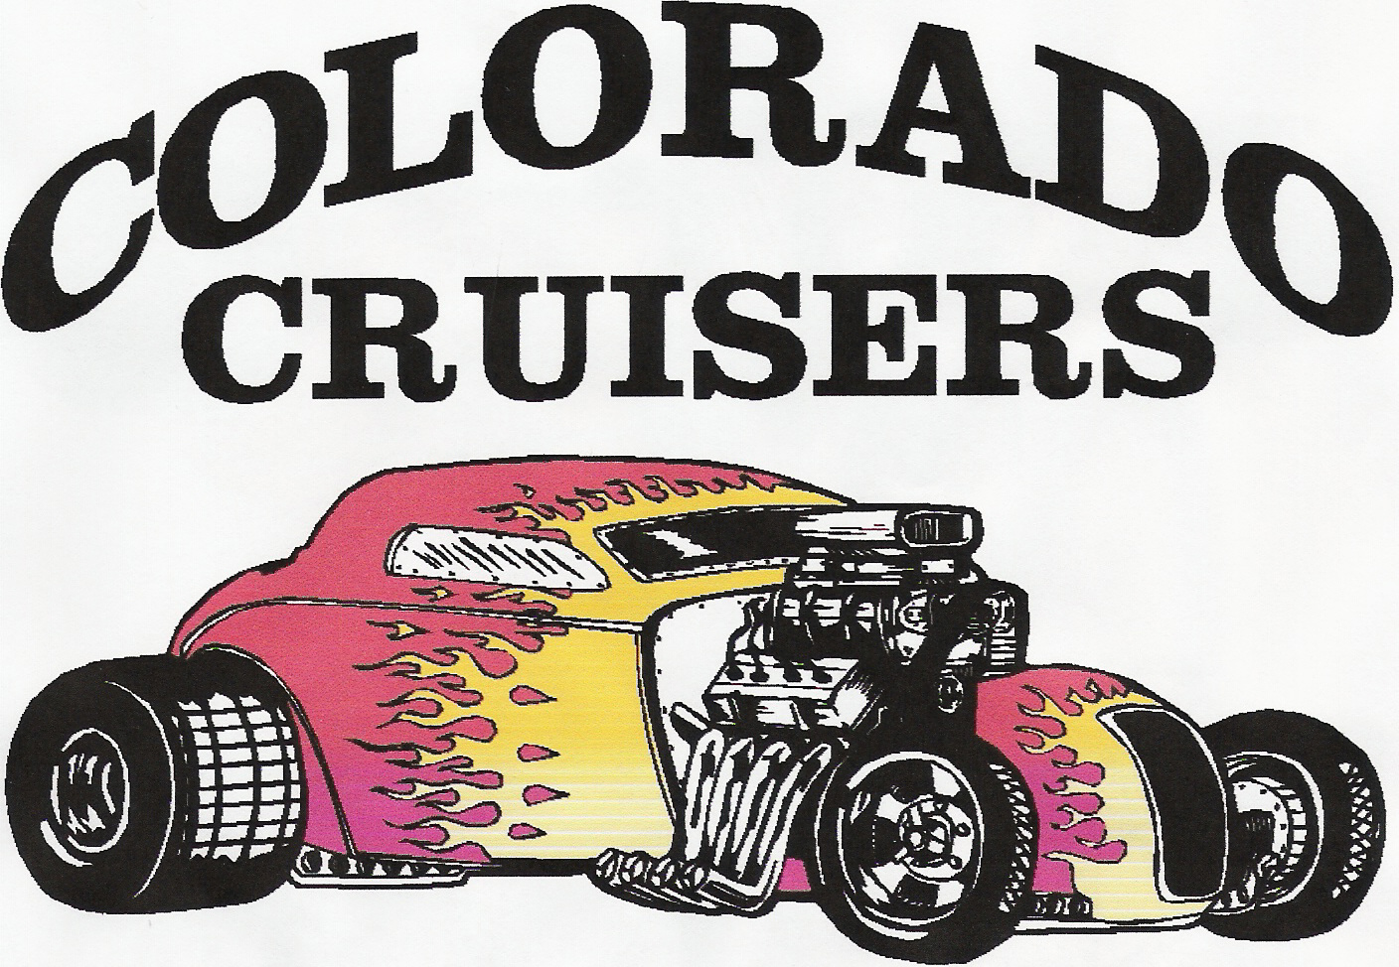
Scholarships for
CNCC Hot Rod and High Performance
Learn how to work on your
Hot Rod – Muscle Car or Classic

The primary goal of the fund is to assist students who have demonstrated the desire and determination to educate and better their knowledge and skills that will enable them to pursue the sport and building of Hot Rods, Muscle Cars and Classics.

This application is open to the public as well as CNCC Students and Colorado Cruisers Club Members.

The applicant must complete the course for which the scholarship is being offered.

Applicants will also be judged based on a one page essay outlining why they desire to take the courses available, what project vehicle they plan to restore if they have one, what their favorite classic, antique or muscle car is and how they plan to put this training to use in their future.

Race, religion, age, ethnicity, physical or mental handicap, or sexual preference will not be considerations for or against eligibility for a scholarship.

The deadline for applying for this scholarship is May 19th.
Applications are available at CNCC or through KRAI at KRAI.COM
Turn applications in to Dave May either electronically or by mail.
Classes will be held in 2 sections, offered at $125.00 each, Section 1, starting May 20th through June 10th and Section 2, June 17th through July 15th on Tuesdays from 6:00-9:30.

For questions please contact:
David May
Program Director of Automotive and Diesel Technology
Colorado Northwestern Community College
Office-Shop 970-824-1108, david.may@cncc.edu
or Steve Lathrop
Auto Tech Instructor
at 970-367-6792, steven.lathrop@cncc.edu

Scholarships for CNCC Hot Rod and High Performance

Name

Current Mailing Address

City State ZIP

Current Phone email address

Male Female Date of Birth / /

CNCC Student Colorado Cruisers Club Member Other

What particular course or courses are you interested in?
Section 1 Engines, Ignition Systems, Diagnostic Tools and Equipment, Mechanical Engine Modifications May 20, May 27, June 3, June 10 (6-9:30 PM)
Section 2 Camshafts, Induction Systems, Computers and Electronic Engine Controls
June 17, June 24, July 8, July 15 (6-9:30 PM)

What particular car, are you interested in modifying or restoring?

What are your long-term goals for your project vehicle?

Please attach your one page essay outlining why you desire to take the courses available, what project vehicle they plan to restore if they have one, what their favorite classic, antique or muscle car is and how they plan to put this training to use in their future.

I permit the use of this information only for the purpose of evaluating my scholarship application, and hereby agree that the information is true to the best of my knowledge.

If selected by the Colorado Cruisers Club, I understand that I will receive a scholarship payment of $350.00 towards the CNCC Hot Rod and High Performance Course that I am taking.

Signature ______________________________________________ Date _________________

